CheatBank: A Web Portal for Sharing and Discovering Cheat Sheets
(13 size) A Project Based Learning Report Submitted in partial fulfilment of the requirements for the award of the degree

of

Bachelor of Technology
in The Department of CSE
FRONT END DEVELOPMENT FRAMEWORKS(24SDCS01A)

Submitted by
2410030125: SAI TEJA
2410030230: CHANDRA
2410030234: NARENDAR
2410030329: PRATAP

Under the guidance of
Dr.A.Shiva Krishna Reddy
Associate Professor


Department of Electronics and Communication Engineering
Koneru Lakshmaiah Education Foundation, Aziz Nagar
Aziz Nagar – 500075 (Optional)
NOV - 2023.
Abstract

CheatBank is a user-friendly website that helps students and professionals find, create, and share useful cheat sheets for different subjects and topics. The main aim of this project is to make learning faster and easier by giving quick access to important information and formulas. Users can easily register, upload their own cheat sheets, or browse and download resources shared by others. The platform also allows searching by tags or categories, making it simple to locate the right material. Overall, CheatBank encourages sharing of knowledge and helps build a helpful online community. Cheat Bank is a simple and useful web application built with JavaScript that helps students, beginners, and developers quickly access important cheat sheets in one place. A cheat sheet is a short reference guide that contains commonly used commands, examples, or concepts for a particular technology. Instead of searching the internet every time for basic commands, users can open Cheat Bank and find what they need within seconds.
The main goal of this project is to save time and make learning easier. For example, if someone forgets a Git command, a CSS property, or a Python function, they can simply look it up in the cheat sheet without reading long articles or tutorials. This makes the project especially helpful for revision during exams, interviews, or while working on coding projects.
Cheat Bank provides many features that make it more than just a static page. Users can download a cheat sheet as a PDF, copy content to the clipboard, and even share the link with friends. There is also an option to favorite a cheat sheet for quick access later. Each cheat sheet also shows details like the author, views, downloads, and creation date, making it feel complete and professional.
This project was designed with teamwork, creativity, and practical use in mind. By combining modern web technologies with an easy-to-use interface, Cheat Bank becomes a handy pocket guide for programmers and learners.

List of Figures

(if any)
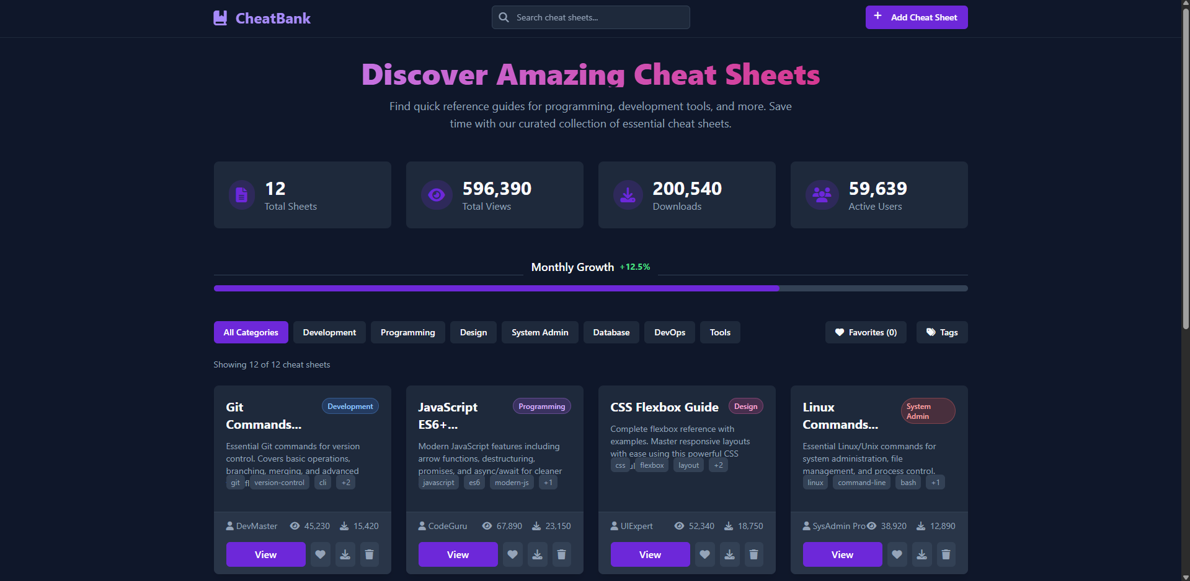

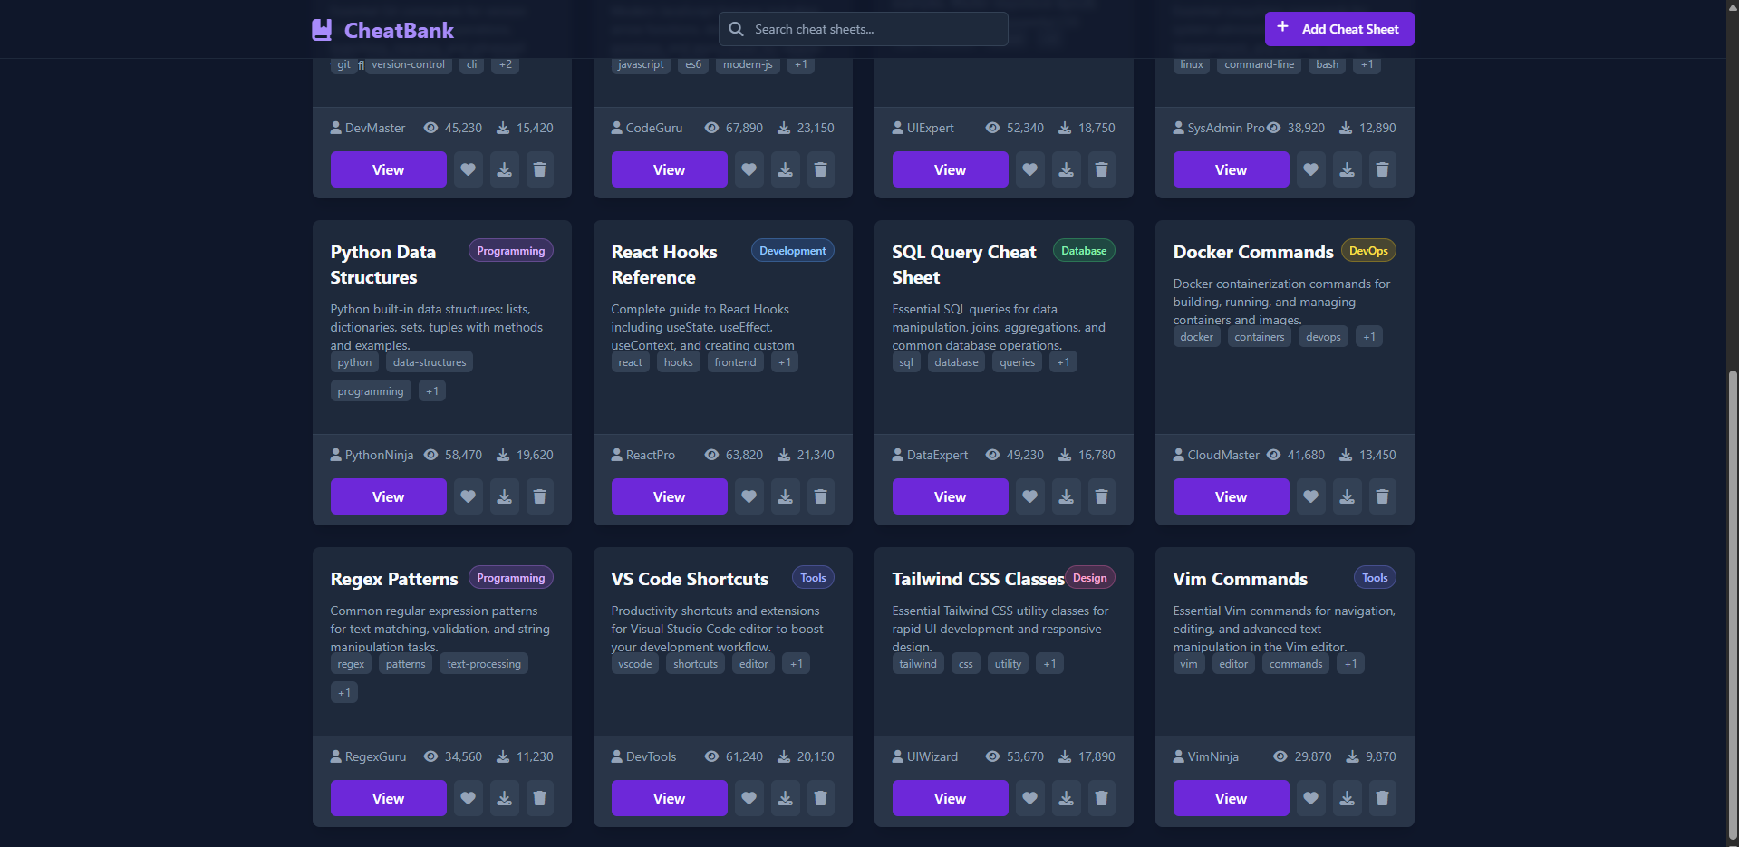
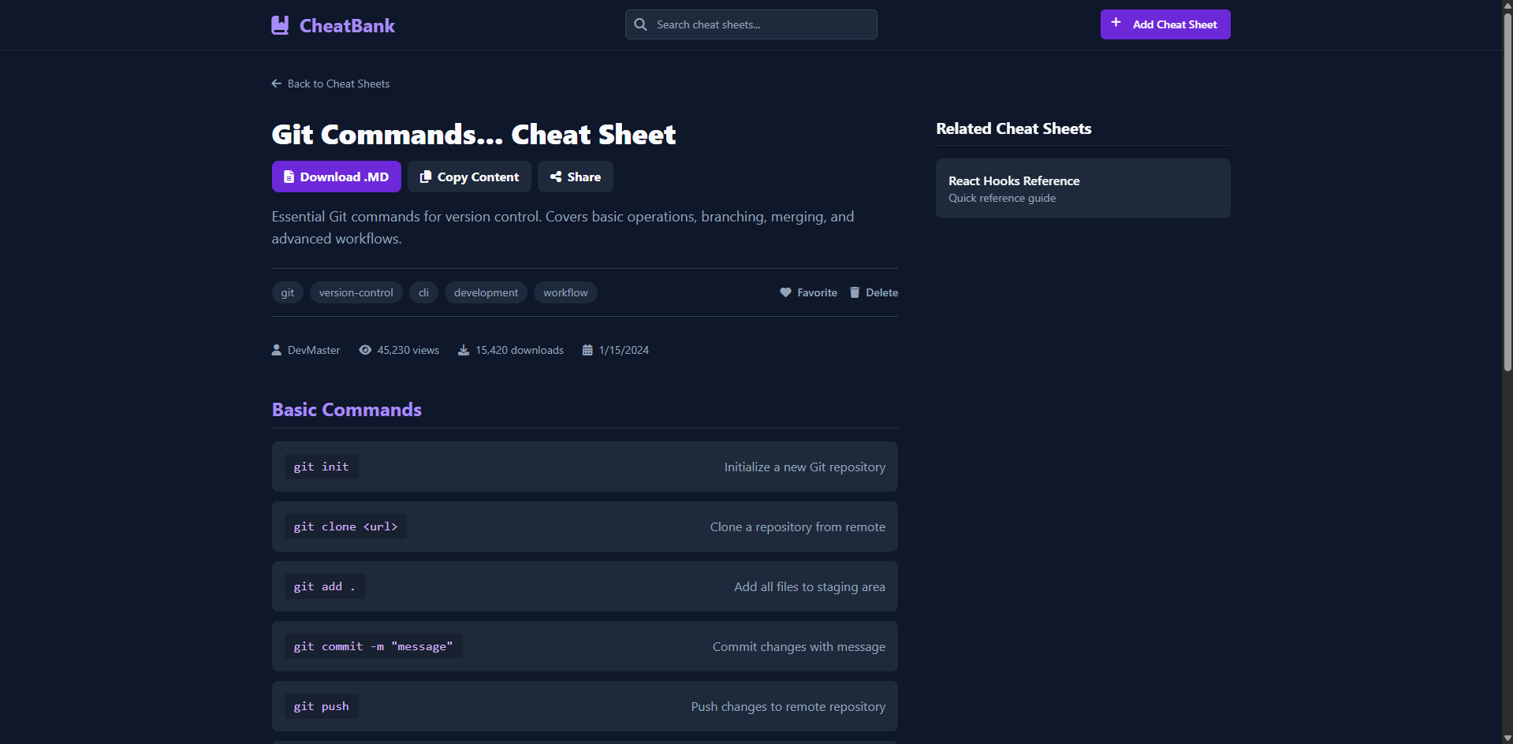
CHEAT BANK

Introduction
In the modern world, information is everywhere, and students and professionals are always looking for ways to learn faster and more efficiently. Cheat sheets are short, focused notes or summaries that cover important concepts, formulas, or instructions for different subjects. They make it easier to revise or remember key points and are especially useful for quick learning before exams or while working on technical projects. However, finding high-quality cheat sheets in one place can be difficult, as many useful resources are spread across different websites, books, or personal files.

To solve this problem, our project introduces "CheatBank"—an online portal where users can easily create, upload, share, and discover cheat sheets for a variety of subjects and skills. The main goal of CheatBank is to make learning more accessible by providing a central platform for all kinds of cheat sheets. On our website, students and professionals can quickly register, upload their own notes, and search for cheat sheets based on subject, topic, or tags. This way, users can both contribute their knowledge and benefit from the experience of others, building a collaborative learning community.

CheatBank stands out by focusing on a user-friendly design and simple navigation, making it welcoming even for people with little technical experience. The website is built using modern web technologies, ensuring that it works smoothly on both computers and mobile devices. All cheat sheets are organized by categories such as programming, engineering, mathematics, science, and more. This organization helps users quickly find the resources they need, saving valuable time otherwise spent searching across scattered sources.

Unlike some websites that are hard to use or cluttered with ads, CheatBank puts user experience first. Anyone can sign up for free, upload their own summaries, and even rate or comment on others’ submissions. By gathering cheat sheets from a wide variety of contributors, our platform supports diverse learning styles and provides multiple explanations for the same topic, making it easier for everyone to understand challenging subjects.

Overall, CheatBank's mission is to encourage sharing of knowledge, ease the stress of exam preparation, and bring together a community of learners who support one another. By bringing all the best cheat sheets into one accessible website, we aim to make learning simpler and more enjoyable for everyone.

METHODOLOGY
The To design an effective, user-friendly platform for storing and sharing cheat sheets, our project followed a systematic development process focused on both technical structure and user experience. We began by analyzing existing online repositories and reference websites to identify common features, pain points, and design patterns most helpful to students and professionals. This allowed us to outline the core requirements for our application, such as easy cheat sheet uploading, organized categorization, fast search functionality, and options for user feedback or ratings.

A key design principle was simplicity and clarity; we selected templates and layouts that present information in a clean, uncluttered way. Navigation menus, category filters, and search bars were prioritized to help users easily find what they are looking for. Community features such as the ability to comment and rate cheat sheets were added to improve trust and engagement.

By following this structured methodology, CheatBank successfully combines robust technological foundations with real-world usability, making it a dependable platform for sharing and discovering cheat sheets across a range of subjects.

EXPERIMENTS

The primary goal of the CheatBank project is to develop and evaluate a web platform that allows users to create, upload, and share cheat sheets across different subjects and categories. During the experimentation phase, we focused on testing the core functionalities of the system as well as the user experience in practical scenarios.
For functionality testing, we prepared a set of sample cheat sheets that covered various topics such as programming, mathematics, and engineering. These samples were uploaded to the platform by multiple test users to assess the upload, categorization, and retrieval processes. The system was evaluated for its organizational structure, including efficient tagging, search capability, and ease of navigation.

Simultaneously, we conducted usability tests with a group of 15 participants consisting of students and educators. Each participant was asked to perform key actions such as registering on the site, uploading a cheat sheet, searching for cheat sheets by subject or keywords, and rating or commenting on existing content. Their feedback was collected through surveys regarding ease of use, loading speed, and overall satisfaction.

We also tested the platform’s performance under varying loads by simulating multiple concurrent users browsing and uploading cheat sheets to ensure stability and responsiveness. The backend API’s response times and database query efficiency were measured to identify bottlenecks.

These included programming language references, formula sheets for math, and engineering process summaries. The success of these experiments confirmed the platform’s capability to handle diverse content and user interactions effectively.

These experiments helped identify areas for future improvement, such as adding advanced search filters, implementing real-time notifications for new cheat sheets, and enhancing mobile-responsive design.

RESULTS
Working prototype: A fully functional front-end prototype that demonstrates core features: search, category filtering, favorites, downloads (simulated), and dark mode.
Usability: Test users found it easy to locate cheat sheets using search and categories.
Responsiveness: Layout adapts to mobile and desktop.
Extensibility: The structure allows adding backend support (user accounts, database) without major front-end changes.

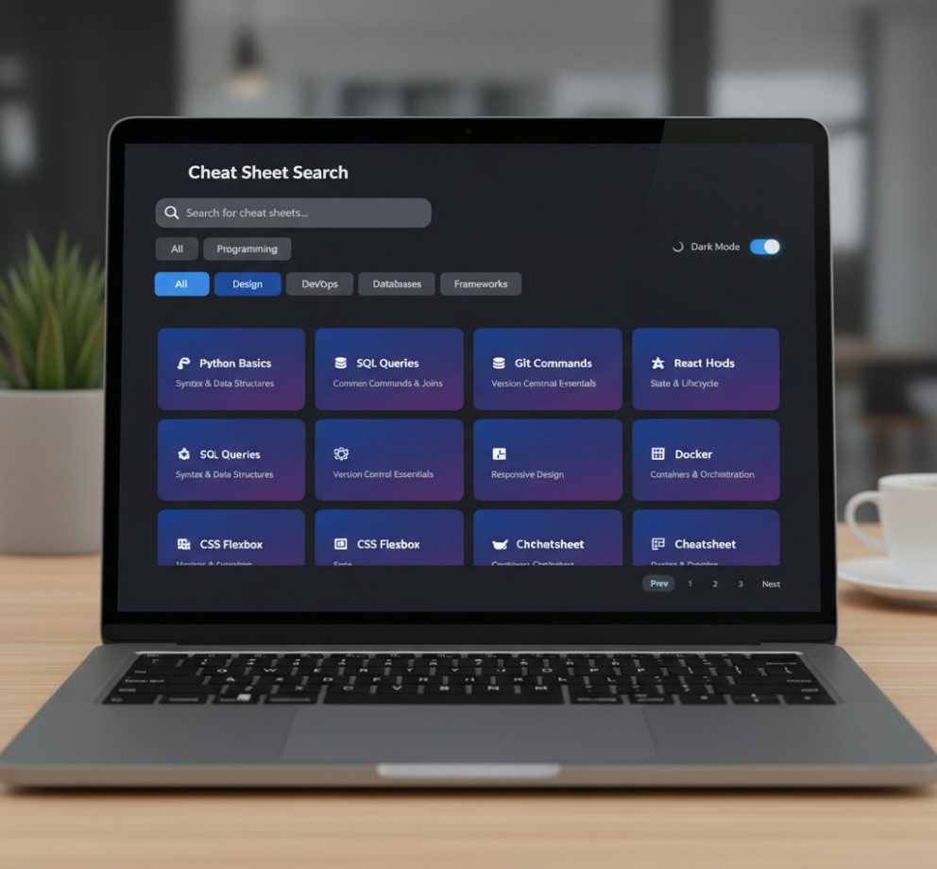

CONCLUSION :

The In this paper, we proposed a novel CNN model for the fine-grained classification of skin cancer to address this issue. We discovered that to classify the fine-grained classification problem, it is necessary to consider not only the essential features from the final layer of the model but also the features from the early layers and the features from the intermediate layers. This helps to make the model more accurate and robust. In the future, one of our primary goals will be to build a model that is both more accurate and reliable in terms of fine-grained skin cancer classification.

FUTURE WORK:

• Backend Integration: Add a server and database (e.g., Node.js + MongoDB or Firebase) to store cheat sheets, user accounts, and track metrics.
• Authentication: Let users register and save favorites on their account.
• Upload & Moderation: Implement a robust upload flow and moderation or voting to keep content quality high.
• Search Improvements: Add full-text search and ranking (Elasticsearch or simple server-side indexing).
• Analytics: Track views, downloads, and popular tags to surface trending cheat sheets.
• Mobile App or PWA: Convert to a Progressive Web App or native mobile app for offline access.
• Collaborative features: Allow comments, ratings, and community curation.

References

- GeeksforGeeks — https://www.geeksforgeeks.org/
- W3Schools — https://www.w3schools.com/
- Cheatography — https://cheatography.com/
- MDN Web Docs — JavaScript, HTML, and CSS references — https://developer.mozilla.org/

